GEOGHANA

# What is GeoGhana?

GeoGhana is a webAPI that provides certain geographical information about Ghana.

## What are the benefits of GeoGhana?

* GeoGhana provides all consumers of the webAPI, information about Ghanas regions, cities and major localities, and it provides said details in that order.
* GeoGhana implements a Postcode system which at present Ghana does not have. This will help make delivery of parcels and letters easier.
* GeoGhana also helps integrate al

# The Postcode System

The Postcode system implemented in GeoGhana is an eight (8)-character postcode. It narrows down locations based on three entities:

1. Region
2. City
3. Locality

## FORMAT OF GEOGHANA POSTCODE SYSTEM

The format used in GeoGhana API consists of two parts. The first part (outward part) consists of three (3) characters and a space, and the last part (inward part) consists of four (4) characters:

AAX_NNAA

A – Alphabet

N – Number

The outward section denotes the region, all regions are suffixed with an X to help denote the region section of the postcode. Thus, there are only two changeable characters for denoting each region. The GeoGhana API accepts only two (2) characters to denote the region, the X is added by the application.

The inward section denotes the city and the locality. The city is denoted by two (2) –digits, and is inputted automatically into the API’s database. Each city is assigned two (2) digits that are unique in its region (other regions may have cities that have the same two (2) – digit number). The last two characters are alphabets that denote the locality.

## SAMPLES FROM THE GeoGhana API

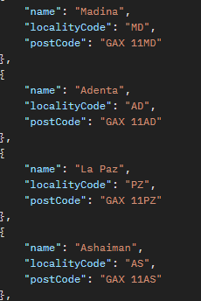

Transcribing from the image above:

|  |  |
| --- | --- |
| Locality – Postcode | Madina – GAX 11MD |
| Adenta – GAX 11AD | La Paz – GAX 11PZ |
| Ashaiman – GAX 11AS |  |

In the case of Madina – GAX 11MD :

GAX, represents the region, Greater Accra Region.

11, represents the city Accra.

MD, represents the localty of Madina.